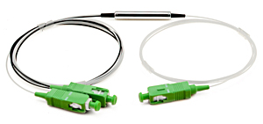 **Gain Flattening Filter**

Auxora's Gain Flattening Filter (GFF) is a filter-based device which features ultra low insertion loss, super thermal stability and excellent reliability. The product uses lead-free packaging platform without epoxy on the optical path. The GFFs provide in-line compensation of the spectral gain profile of EDFAs, and can be used for high-power applications in DWDM system.

***FEATURES***

* Low insertion loss
* Flat Spectral Gain
* Exceptional reliability and stability
* Epoxy free optical path
* Telcordia GR-1221 and GR1209 Compliant

***APPLICATIONS***

* Fiber Optic Amplifier

|  |  |  |
| --- | --- | --- |
| **Parameters** | **Unit** | **Value** |
| Operating Wavelength Range | nm | Refer to target curve |
| Peak Insertion Loss | dB | ≤0.5 |
| Peak to Peak in Error Function Range | dB | ≤0.5 |
| Optical Return Loss (Input & Output) | dB | ≥50 |
| Polarization Dependent Loss | dB | ≤0.1 |
| Polarization Mode Dispersion | ps | ≤0.05 |
| Temperature Dependent Loss | dB | ≤0.15 |
| Maximum Power Handling | mW | 500 |
| Operating Temperature | °C | 0 ~ 70 |
| Storage Temperature | °C | -40 ~ 85 |
| Humidity | -- | 5 ~ 95% |
| Package Size | mm | Standard: Φ5.5xL34（L40 for 900um loose tube）  Mini Size: Φ3.0xL25 |
| Fiber Type | -- | ITU-T G657.A |

**SPECIFICATIONS**

**NOTES:**

1) All specifications are based on the devices without connectors, and guaranteed over wavelength, polarization and temperature.

2) PMD and chromatic dispersion values are guaranteed by design.

3) IL is 0.3 dB higher, RL is 5 dB lower for each connector added

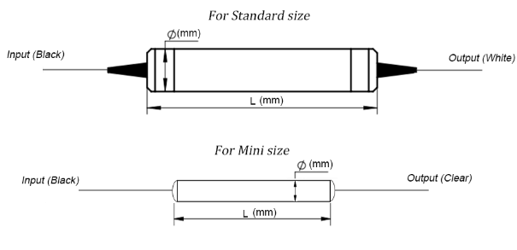

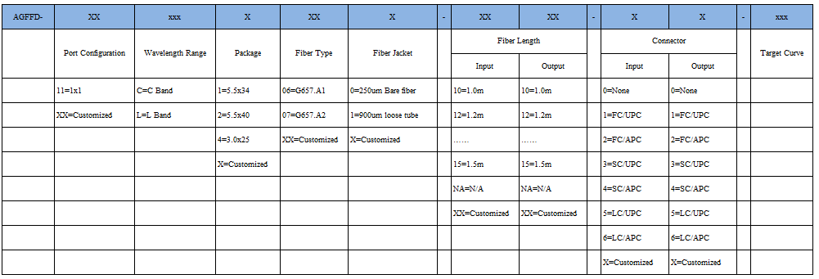

**Ordering Information: (e.g.AGFFD-11C1060-1010-00-004)**

**Spectrogram(e.g. typical curve)**

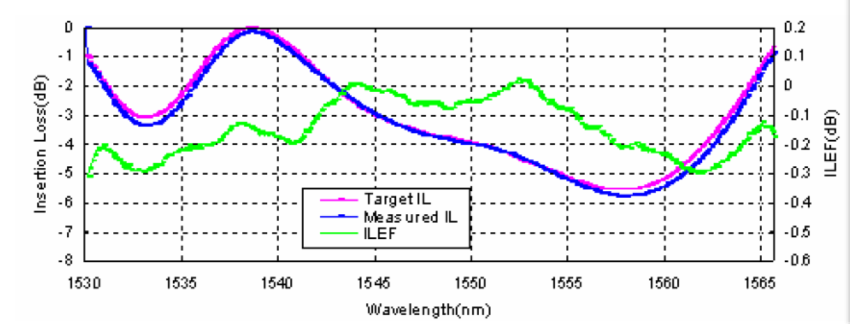

**Packing Dimensions(mm)**